Table 1. AICc values for generalized linear mixed models for each species planted in fenced and unfenced seedling plots.

|  |  |  |  |
| --- | --- | --- | --- |
|  | **AICc value** | |  |
| **Species** | **null** | **treatment** | **difference** |
| *Carica papaya* | 155.81 | 121.13 | 34.68 |
| *Psychotria mariana* | 100.51 | 78.39 | 22.12 |
| *Morinda citrifolia* | 114.55 | 105.27 | 9.28 |
| *Premna serratifolia* | 94.17 | 86.4 | 7.77 |
| *Aglaia mariannensis* | 79.36 | 79.88 | -0.52 |
| *Ochrosia oppositifolia* | 46.22 | 48.94 | -2.72 |

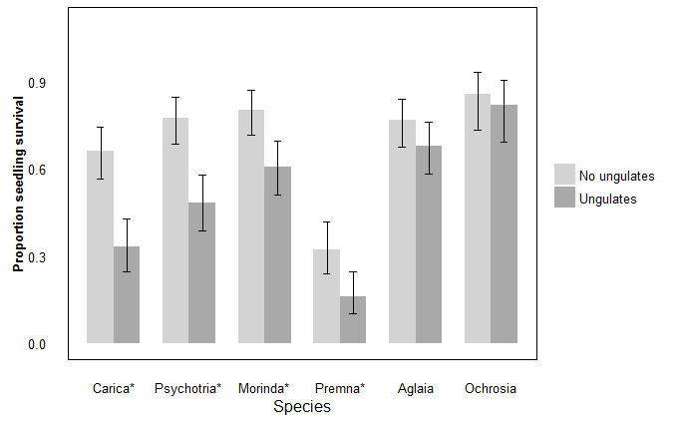

Figure 1. A higher proportion of seedlings remained alive in fenced versus unfenced plots for four out of six forest species, indicated with *. The best fit model for proportion alive included treatment, and in all cases, proportion alive inside fenced plots with “No ungulates” was higher than outside fenced plots with “Ungulates.” For *Aglaia mariannensis* and *Ochrosia oppositifolia* seedlings, treatment did not contribute to the best fit model explaining proportion of seedlings alive, and proportion of seedlings alive did not differ significantly due to treatment.

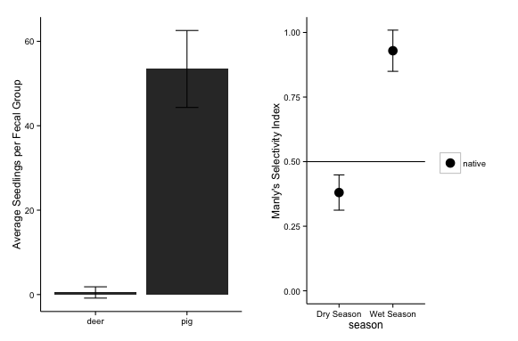

Figure 2. The average number of seedlings that germinated per faecal group was larger from pigs (n= 31 faecal groups with an average of 53.45 ± 9.12 seedlings per faecal group) than from deer (n=20 faecal groups with an average of 0.5 ± 1.34 seedlings per faecal group)(left panel). Manly’s Selectivity Index was calculated for pig faecal groups collected during dry season, and for pig faecal groups collected during wet season. While there was a small difference in selectivity during dry season, showing selection for exotic species, there was a strong selection for native species during rainy season. Values for this index for exotic species are equivalent to the value for native species subtracted from 1.

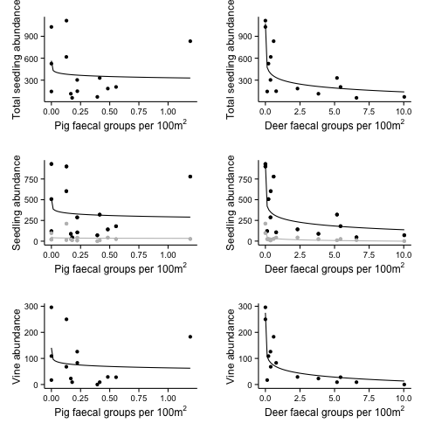

Figure 3. In the left-hand column, regression analysis between abundance of pig faecal groups (relative index for population abundance) showed no relationship with total seedling abundance, exotic nor native seedling abundance (middle row, with black line for native and gray line for exotic), nor vine abundance per survey site in Guam. In the right hand column, abundance of deer faecal groups (relative index for population abundance) show strong negative loglinear relationships to total seedling abundance (r2 = 0.710), native seedling abundance (r2 = 0.647), exotic seedling abundance (r2 = 0.696), and to vine abundance (r2 = 0.751).